THANK YOU to our 2020 PtHAWW sponsors. We appreciate you SO VERY VERY MUCH!!!!

Tina Johnson
Teri Blair
Sondrea & Jean Garcia
Kathy Good
Lyndsey Mooth
Tami Wojcek
Cheryl Wright
Cook’s Country Creations
Joan Storlie
Shannon Prigger
Lana & Samantha Weinmann
VanMar Arabian/Pintos
Beth and Violet Adams
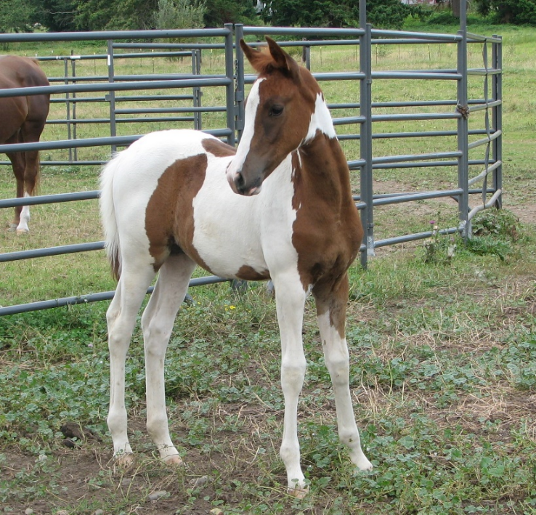
Libbee Shell

